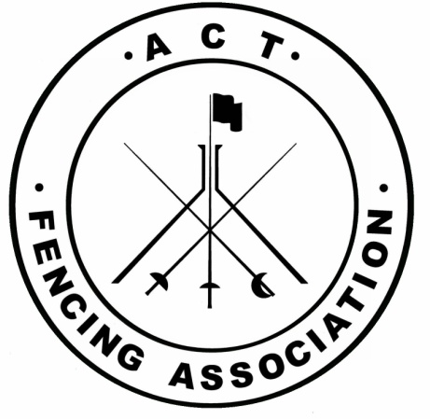
ACT Fencing Association (ACTFA)
Strategic Plan 2017 to 2022
Strategic Vision
Our vision is to develop ACT fencing to be recognised by the ACT general community as safe, inclusive, valued, and challenging with sporting opportunities available for all sections of the community.
Strategic Goals
- Goal 1. ACTFA will work collaboratively with the ACT fencing clubs to develop quality pathways which provide beginners and competitive fencers with positive experiences.
- Goal 2. ACTFA promotes and grows the profile of fencing in the ACT.
- Goal 3. ACT fencing community is recognised throughout Australia as having credible levels of fencing training, competition, sporting expertise, and tournament achievements.
Brand Values
- A fun, enjoyable sport
- A sport with a difference
- A physically and mentally challenging sport
- A sport which is easily accessible by all age groups, genders, and levels of ability
What is the role of ACTFA?
- Supporting clubs
- Running successful events
- Setting policy for the conduct of fencing in the ACT
- Linking clubs to the Australian fencing Federation (AFF)
- Communicating with the broader (fencing) community in the ACT

How do we get there?
Strengths :
- Geographical Nature and the Location of the ACT
- Collegiate nature of clubs
- Dedicated committee
- Brand – Olympic sport, individual nature, sword fighting element
- Facilities (TAC, and AIS plus fencing clubs at UNSW/ADFA, ANU, St Mary McKillop High School, Kaleen Primary School, and Lancaster Hall, Wesley
- Close relationship with the National body, the Australian Fencing Federation (AFF)
- Alignment with ACT Active 2020 Plan
Impediments to delivery:
- Low number of coaches and officials
- Finances (stable funding , sponsorships)
- Human resources (Volunteers, Administers, etc)
- Misconceptions (cost of the sporting equipment, insurance)
- Competitive sporting environment
- Low profile sport
Key Result Area (KRA) | Key Objectives | Key Objective Performance Indicators | Drivers of the KRA | Key Strategies | Performance Indicators
- Membership and Participation | - Retain people in the sport  - Increase memberships  - Obtain medium Sporting organisation status | - ACTFA has 250+ members  - ACTFA is a Tier 2 sporting organisation | - Clubs  - Events  - Value proposition  - Alignment with ACT Active 2020 Plan  - Equipment | - Grow membership in clubs  - Work with clubs to automatically affiliate beginners  - Increase the number of fencers in school programs | - Increased participation  - Promote Register Now and portal use at club  - Promote senior and school fencing  - Increase in Annual Operational Funding from ACT Government
- High Performance (HP) | - Increase representative fencers  - More medals  - Program focussed on juniors | - Junior Fencers (U17/U15/U13) in top 8 nationally | - Strong fencers  - Coaches  - Administration of HP  - HP policy  - AFF HP Policy | - Utilise AFF National camps and competitions  - Leverage support and direction from AFF  - Develop HP policies  - Develop ACT HP squad | - Maximise ACTFA fencers participating in AFF National Camps  - HP Polices linked to AFF HPP plan  - HP Squad training
- Competitions and Events | - Host National competition  - Host International competitions  - Develop regional opportunities for juniors  - Maintain healthy local circuit | - Competitions for all levels of fencing in all 3 weapons, at International, National and State level | - Branding  - Resources | - Conduct annual review of competitions  - Liaise with AFF to regularly host national event  - Bid for International events  - Focus on school’s event/league | Retain events program:  - 1 national event  - 1 state events  New Event:  - 1 international event  - School League
- Pathways | - Athletes  - Coaches – align with AFF  - Officials – align with AFF  - Administrators | - ACTFA feeding into National Fencing | - Frameworks  - Policies  - Alignment with AFF  - Incentives for competitors, coaches and officials | - Create framework  - Develop policy  - Implement pathways | - Framework linked to AFF Pathways  - Close co-operation and alignment with AFF  - Pathways implemented
- Governance | - Develop annual operational plan  - Maintain good practice  - Conform to ACT Government guidelines | - “Best practice” Committee  - Revised Constitution | - Local committee  - Active Canberra | - Develop position/role descriptions for committee  - Annual review of operations  - Capitalise on opportunity provided by relationship with Active Canberra | - Annual report to committee
- Communication, marketing and sponsorship | - Develop and maintain regular presence in the media  - Communicate with interstate fencers  - Communicate with local fencers  - Sponsors | - ACTFA has a solid partnership with an event sponsor  - ACTFA will promote partnerships local small business  - Support ACT government programs that promote sports to the community | - Communication tool  - Communication plan  - AFF and ACTFA Publicity officer  - Active Canberra | - Continue to work with Active Canberra  - Focus on a specific market  - Define products  - Obtain event based Sponsorship | - Work with AFF Communication Director and staff  - Improving relations with local media
- Infrastructure | - Assistance to clubs accessing venues  - Equipment | - Support ACT communities and small business by diversifying use of venues across the ACT | - Active Canberra liaison officer  - ACTFA Committee  - Sustainability | - Review of clubs’ equipment  - Review venues in ACT  - Support equipment officer  - Identify equipment sources | - Regular Report to Committee  - Venues Officer appointed annually  - Regular Report to Committee  - Equipment Officer appointed annually

