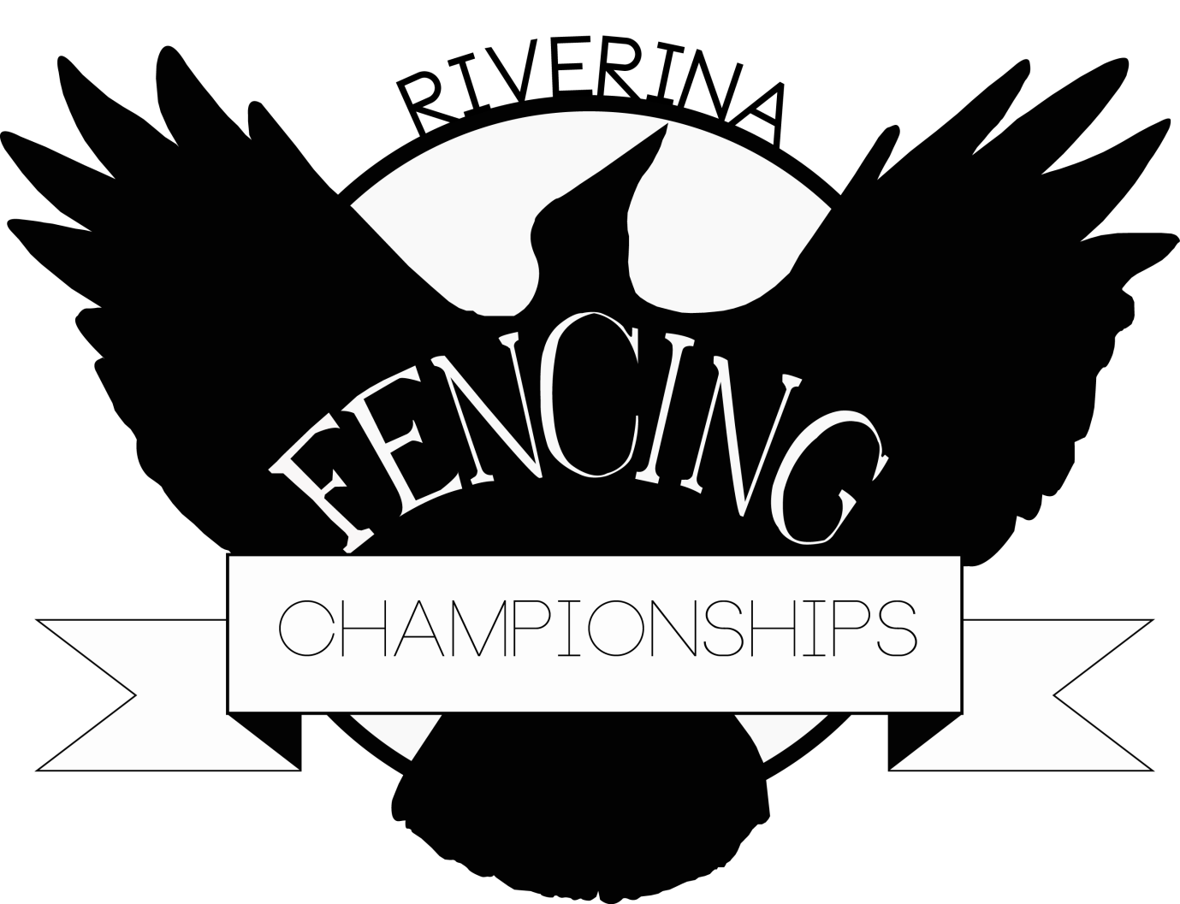
When: 23rd and 24th September 2017
Where: The Riverina Anglican College, Farrer Rd Wagga Wagga (Near main entrance to Charles Sturt University)
Registrations close 15min before posted start times
Start Times: Saturday: Sunday:
9:15am: Open Foil 9.00am: Open Epee
11.00am: Novice Sabre 10.30am: U/15 Foil
12:30pm: U/13 Foil 12.30am: Open Sabre
13:30pm: Novice Epee 13.30pm: Novice Foil
Cost: Entry Fee $25 for the first event ($15 for each other event). Pre-registration will receive a $5 discount on each event. Pre-registration closes 16th September.
Entrants must be registered with NSW Fencing Association or their State Association.
There will be some equipment available for hire (let us know in plenty of time) Tracksuit pants may be worn in novice events. Electric bib for foil is not required.
Contact : Julian on 0409 227 955 or email ; julian1fencing@gmail.com

There will be a dinner on the Sat evening at the end of the days events. Everyone welcome to enjoy a friendly meal with all your fencing friends. Adults $25, children $15, Family $50 (2A,2C)
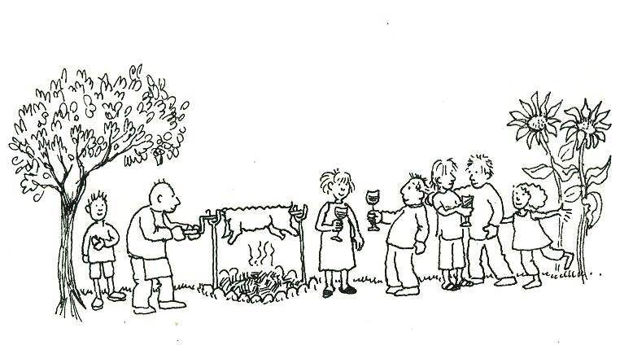
Please indicate your attendance (and the number in your party) when you pre-register. These numbers are essential for catering purposes.

More information contact Julian at julian1fencing@gmail.com

