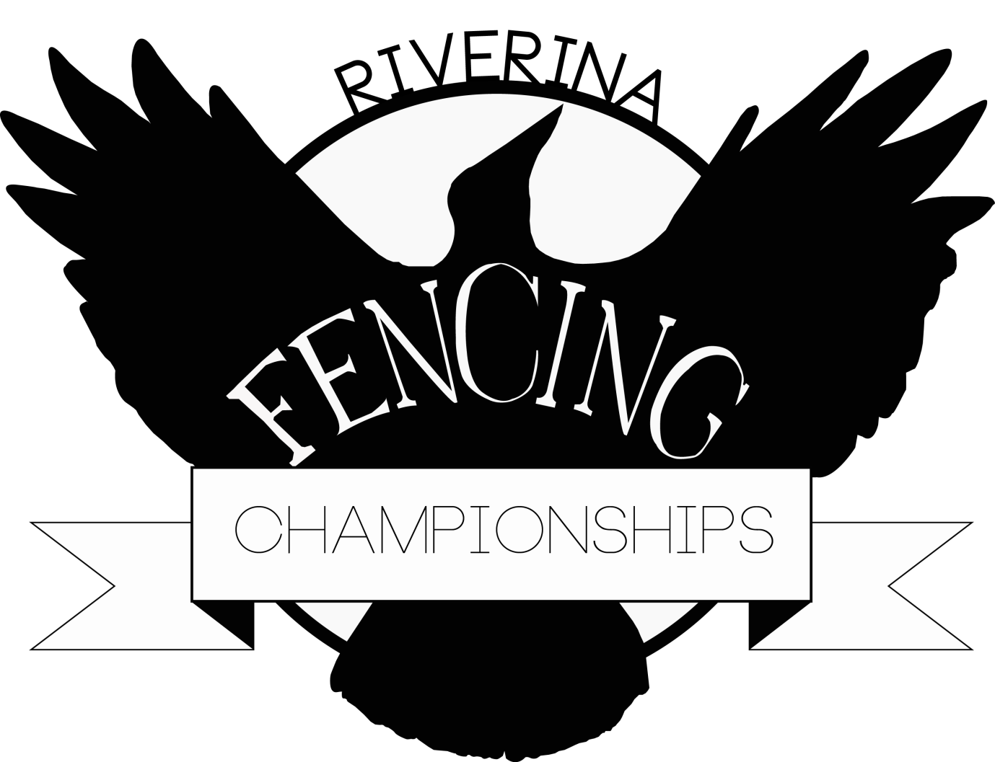

**When:** 17th and 18th September 2016

**Where:** The Riverina Anglican College, Farrer Rd Wagga Wagga (Near main entrance to Charles Sturt University)

**Registrations close 15min before posted start times**

**Start Times: Saturday: Sunday:**  
 9:15am:  Open Foil 9.00am: Open Epee  
 11.00am:  Novice Sabre 10.30am: U/13 Foil  
 12:30pm:  U/15 Foil 12.30am: Open Sabre  
 13:30pm:  Novice Epee 13.30pm: Novice Foil

**Cost:**  Entry Fee $25 for the first event ($15 for each other event). Pre-registration will receive a $5 discount on each event. Pre-registration closes **9th September**.

Entrants must be registered with NSW Fencing Association (minimum Associate Member) or their State Association.

*There will be some equipment available for hire (let us know) Tracksuit pants may be worn*

**Contact :** Julian on 0409 227 955 or email ; [julian1fencing@gmail.com](mailto:julian1fencing@gmail.com)

**There will be a** **dinner on the Sat evening at the end of the days events. Everyone welcome to enjoy a friendly meal with all your fencing friends. Adults $20, children $15, Family $50 (2A,2C)**

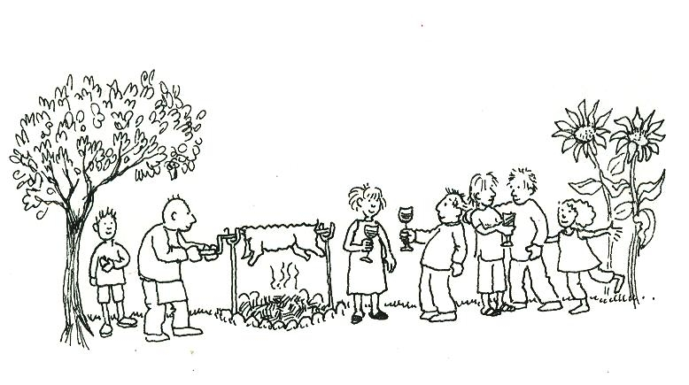

**Please indicate your attendance (and the number in your party) when you pre-register. These numbers are essential for catering purposes.**

More information contact Julian at [*julian1fencing@gmail.com*](mailto:julian1fencing@gmail.com)

**With the generous support of the**

