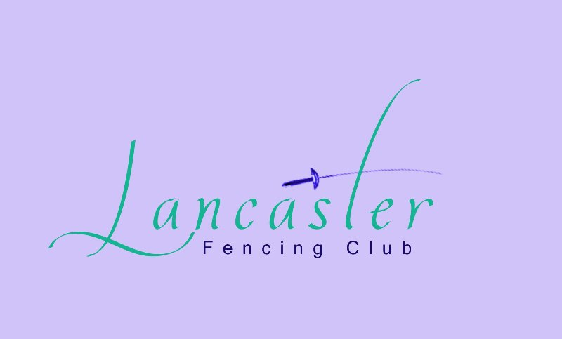

5-week Beginner Level Fencing Course in Term 1, 2015

SESSIONS: Wednesdays 6.45 – 8.00 pm for four weeks
March 11 – April 8

LOCATION: Lancaster Hall, Wesley Uniting Church, Corner National Circuit and Fitzroy Street, Forrest.

COST: $50 for the 5-week course payable by cash/cheque at first session or bank transfer:
Account name: Wesley Fencing at Lancaster Hall
BSB: 062 900 Account: 1060 4316 Ref: RN-{Your Name}
+ $40 for beginner registration (to cover insurance). Please register online with payment by credit card at http://www.actfa.org.au/home/2015-online-membership-form

- Participants must be a minimum of 13 years of age
- Under 13’s are welcome provided a parent also takes the course
- Wear long track pants, long-sleeved sweatshirt and trainers/sneakers
- Bring a glove to protect your fencing hand (left/right handed)
- All specialised fencing equipment (foil, mask and plastron) is provided
- Sessions presented by experienced coaches in a friendly club environment

To register your interest and for more details please contact ANNA ROBINSON, Principal Coach, Wesley Fencing at Lancaster Hall / Lancaster Fencing Club

Email: anna.robinson@bigpond.com
Mobile: 0409 773 747

