- If you’ve never competed and want to try a safe and easy way to get started, or
- If you’ve just started competitive fencing and want to develop your skills, or
- If you just want to have fun with your fencing friends,
Then the Novice Foil Teams Fencing Competition is for you!
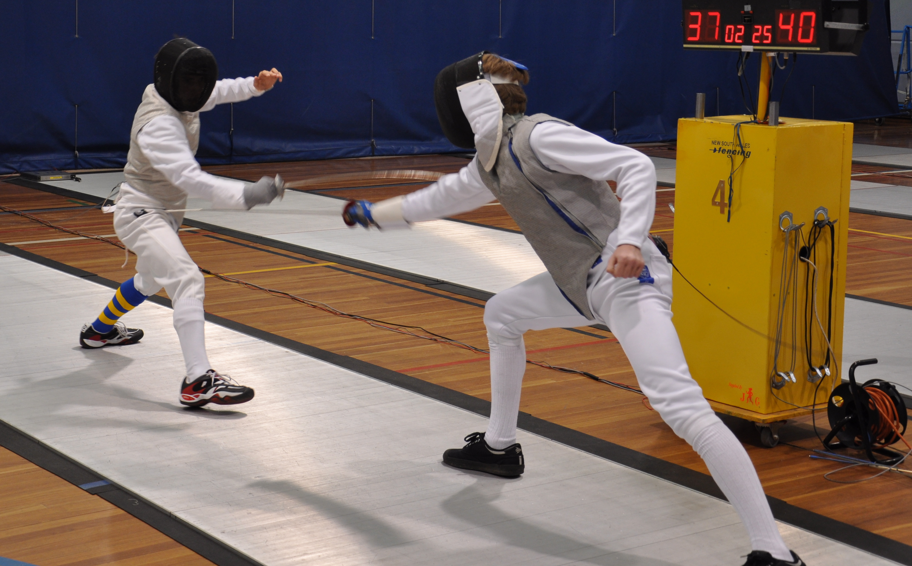
Open to male and female fencers. No age restrictions. The winning team will win 2013 National Championship T-shirts.
No Entry Fee. Pizza and soft drinks will be provided for fencers and fans.

Location: Lancaster Fencing Club, Wesley Uniting Church Complex, Corner National Circuit and Fitzroy Street, Forrest
Date: Wednesday, 18 September 2013
Time: Registration closes 6:45 PM, Competition starts 7:00 PM sharp! Leave time to warm up.
Weapon: Foil only. Fencing is electric, so bring electric weapon and body wire if you have them.
Teams: Male, female or mixed. 3 per team and up to one substitute. Individuals also welcome; we can place you in teams.
Clothing: Track suit pants are okay – please wear underplastron, jacket, mask and lame if you have them. Some equipment available for borrowing on the day – please let us know when you pre-register what you need.

Contact Lancaster.delegate@actfa.org.au to pre-register or ask any questions. To pre-register, which we strongly encourage, send the names of 3-4 team members (who must be AFF-affiliated) and a team name. Or pre-register as an individual.

* - In the ACT, you are a novice fencer until 31 December of the year two years after your first competition. Basically, if your first official competition was in 2011 or later (or never!) you are probably a novice. An exception is if you have come in the top three in any state-level competitions. If you are not sure, contact Lancaster.delegate@actfa.org.au

