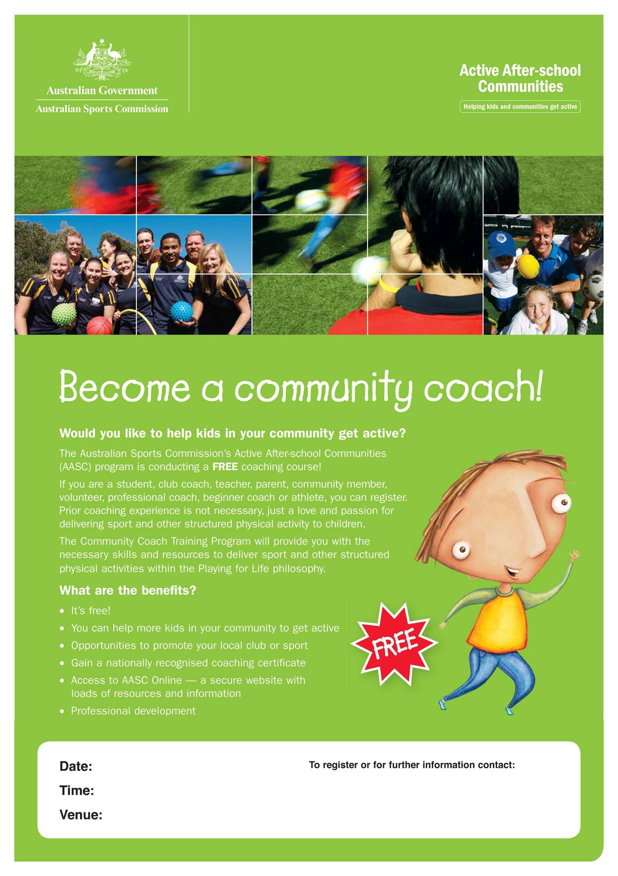
Tuesday 7th/Wednesday 8th June
6.00pm-9.00pm
Meet at Silver Room, AIS
Kristy Giteau
Ph: (02) 6214 1436
Kristy.giteau@ausport.gov.au

