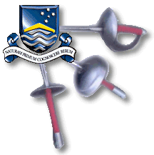 | Australian National University  2010 Annual Fencing Competition
The ANUFC presents its Annual Open Fencing Competition
Saturday 24th July 2010 Open Individual Foil: 9:45 am
Sunday 25th July 2010 Open Individual Epee: 9:45 am
Team events will follow individual events. Cost is $20 per weapon, $30 for both and $20 per team.

Minimum clothing is fencing jacket and long pants.

Contact: Justin Bewsher on 0421 986 310 or justin.bewsher@gmail.com

ANU Sport and Rec Centre
Building 19, North Road Off Barry Drive
