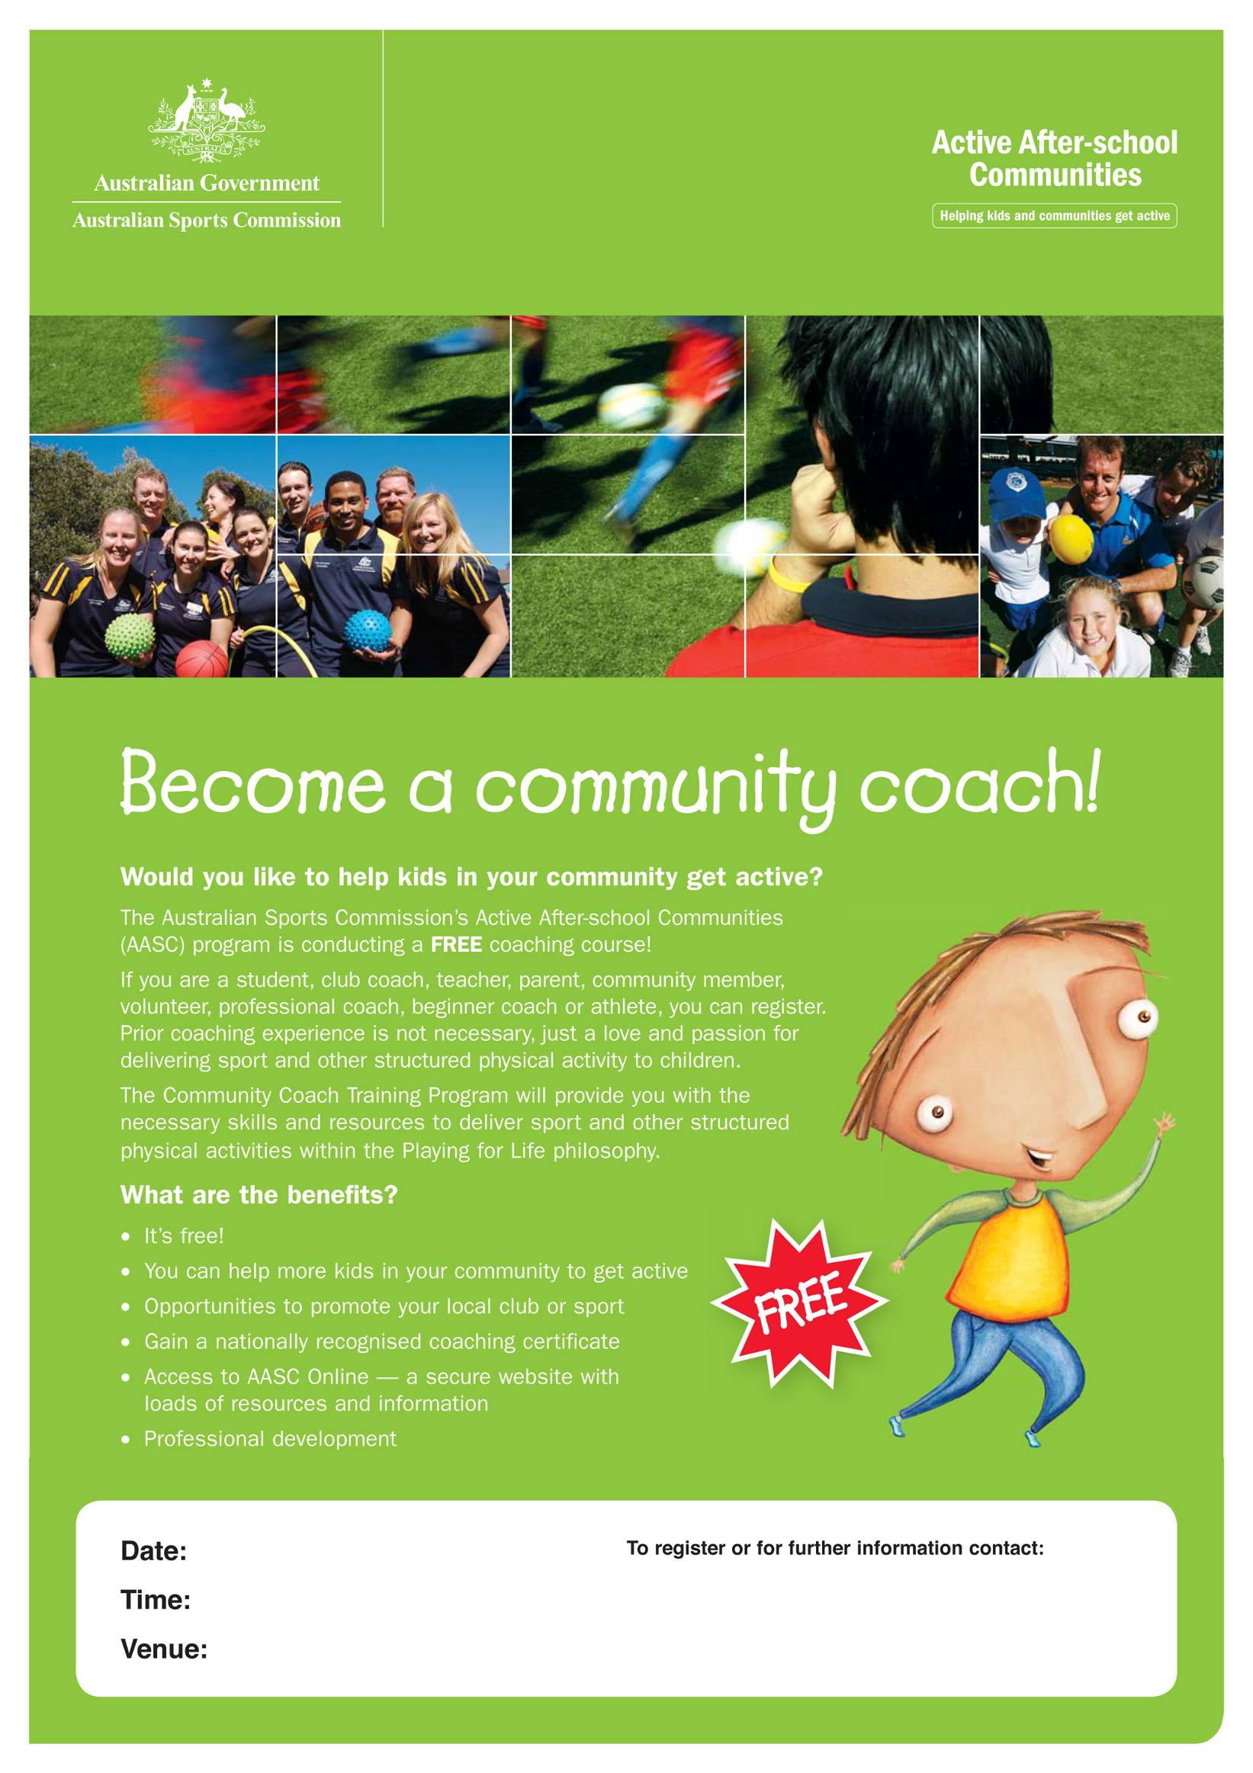
Sunday, ^{2nd} May
10:00-5:00pm
Silver Room, AIS
Kristy Giteau
Ph: (02) 6214 1436
Kristy.giteau@ausport.gov.au

